Mini Project Report
on

platepal

Submitted in partial fulfillment of the requirements for the
degree

Second Year Engineering – Computer Science and Engineering (Data Science)
by

Under the guidance of
Ms Priyanka karhade project By
Soham Padture- 23107100 Aryan Kamath – 24107110 Manas More -24107040
Sarvesh Nawghare- 23107132

DEPARTMENT OF COMPUTER SCIENCE AND ENGINEERING (DATA SCIENCE)
A.P. SHAH INSTITUTE OF TECHNOLOGY
G.B. Road, Kasarvadavali, Thane (W)-400625
UNIVERSITY OF MUMBAI
Academic year: 2025-26



CERTIFICATE

This is to certify that the Mini Project report entitled "PlatePal: A Sustainable Food Rescue Platform using Flutter & Firebase" is a bonafide work carried out by: Soham Padture-23107100, Aryan Kamath-24107110,Manas More-24107040,Sarvesh Nawghare-23107132. The above students are bonafide students of A. P. Shah Institute of Technology, Thane, and have completed this project in a satisfactory manner as partial fulfillment of the requirement for the degree of Bachelor of Engineering in Computer Science and Engineering (Data Science) under the University of Mumbai during the academic year 2025-2026.

Ms. Priyanka karhade
Guide

Dr. Pravin Adivarekar Dr. Uttam D. Kolekar
HOD, CSE (Data Science) Principal

External Examiner: Internal Examiner:
2. 2.

Place: A. P. Shah Institute of Technology, Thane

Date:

ACKNOWLEDGEMENT

This project would not have come to fruition without the invaluable help of our guide Ms. Priyanka karhade . Expressing gratitude towards our HoD, Dr. Pravin Adivarekar, and the Department of Computer Science and Engineering (Data Science) for providing us with the opportunity as well as the support required to pursue this project. We would also like to thank our project coordinator Ms. Richa Singh and Mr. Kiran Gaikwad who gave us her valuable suggestions and ideas when we were in need of them. We would also like to thank our peers for their helpful suggestions.

TABLE OF CONTENTS
.Introduction 1
1.1Purpose 1
1.2Problem Statement 1
1.3Objectives 2
1.4Scope 2
- Proposed System 3
2.1Features and Functionality 3
- Project Outcomes 5
- Software Requirements 7
- Project Design 9
- Project Scheduling 11
- Results 12
- Conclusion 14
References

Chapter 1 :Introduction
Hackathons have become a vital part of the technical education ecosystem, encouraging innovation, teamwork, and rapid prototyping. However, participants often face challenges in forming balanced teams with the right mix of skills, and organizers struggle to manage events and provide fair evaluation. The aim of this project is to develop a centralized mobile platform – CodeClub – that simplifies team formation, collaboration, and evaluation for hackathons.

Purpose
The purpose of PlatePal is to create a sustainable ecosystem that bridges the gap between local food retailers and eco-conscious consumers. By providing a digital marketplace for "Surprise Bags"—consisting of perfectly edible but unsold surplus food—the application aims to minimize food waste, promote environmental responsibility, and provide affordable food options to the community..

1.2 Problem Statement
Global food waste is a critical issue, with nearly one-third of all food produced intended for human consumption being wasted. Local businesses (bakeries, restaurants, and grocers) often struggle to manage end-of-day inventory, leading to massive amounts of fresh food being discarded. Simultaneously, consumers are facing rising food costs and lack a convenient platform to discover and rescue these surplus meals at a discounted price.

Objectives
    - Waste Reduction: To significantly reduce the volume of edible food ending up in landfills by facilitating its redistribution..
    - Economic Recovery: To help local businesses recover costs on surplus inventory that would otherwise be a total loss.
    - Affordability: To make high-quality food more accessible to students and low-income individuals through a 50-70% discount model.
    - Community Engagement: To foster a community of "Food Heroes" who are actively involved in local sustainability efforts.

Scope
- Real-time discovery of nearby surplus food via Google Maps integration, secure reservations, and live order tracking..
- A dashboard for businesses to manage inventory, update "Surprise Bag" contents, and track sales performance..
- An automated system to calculate environmental savings (CO2 and weight) based on successful rescues, displayed via interactive charts
- Automated alerts for pickup windows, reservation confirmations, and nearby "flash sales" to ensure high rescue rates.
- A robust mobile architecture built on Flutter, ensuring a high-performance experience on both Android and iOS devices.

Chapter 2 : Proposed System

platepaal is designed as a cross-platform mobile application built with Flutter and Firebase. It consists of three main user modules: Admin, user, , and ui ux. The backend uses Firebase services for authentication, real‑time data storage, and file management.

Features and Functionality
Feature 1:Real-time Surplus Discovery

    - Admins An interactive Home feed displaying available "Surprise Bags" from local bakeries, cafes, and restaurants with real-time stock counts.
Feature 2: Intelligent Search & Filtering

- Users can search by keywords (e.g., "bakery", "near me") and filter results by food Feature 3: Team-Specific Communication

    - Integration with Google Maps to visualize nearby food rescue opportunities, allowing users to browse retailers geographically
Feature 4: Secure Reservation System

    - A streamlined checkout process where users can reserve surplus bags and select specific items before they are wasted..

  - Block Diagram:
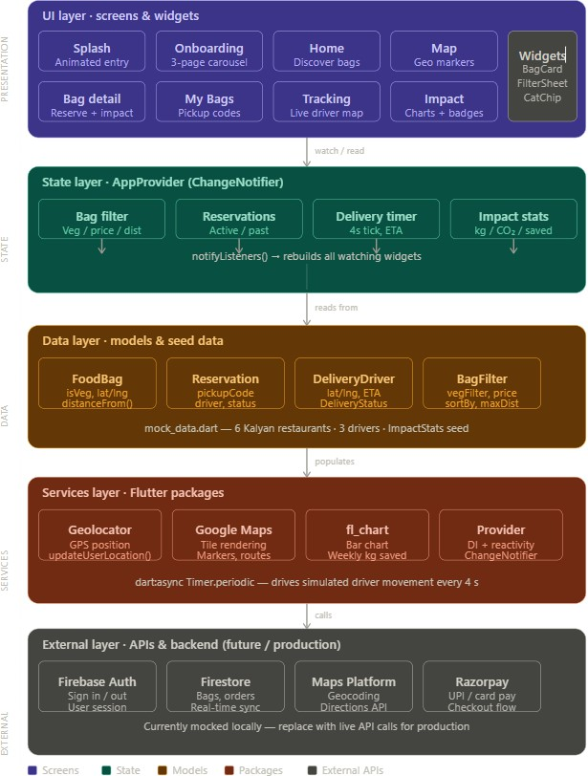
d

Chapter 3 : Project Outcomes
The final deliverables of the Hackmate project are categorized into functional outcomes and technical deliverables.

3.2 Functional Outcomes
- Reduction in Local Food Waste

  - Admin can register with email/ Outcome: A measurable decrease in the volume of surplus food discarded by partner retailers. By digitizing the inventory of unsold goods, the app converts potential waste into successful "rescue
- Enhanced Community Accessibility

  - . Improved access to high-quality, nutritious meals for cost-sensitive demographics (such as students and low-income families). The 50-70% discount model ensures that sustainable eating is financially viable for everyone.
- Real-time Geospatial Connectivity

  - Seamless connection between consumers and nearby businesses. Through Google Maps integration, users can identify and navigate to food rescue points within their immediate vicinity, minimizing the travel distance and associated carbon emissions.

- Behavioral Change through Data Visualization

  - Outcome: Increased user awareness of environmental issues. By seeing their cumulative impact (Kg saved/CO2 prevented) on a personal dashboard, users are incentivized to adopt more sustainable long-term consumption
habits.

3.2 Technical Deliverables
- High-Performance Mobile Application – A fully functional Flutter application package.
- Centralized State Management Architecture - An AppProvider layer implementing the ChangeNotifier pattern.

- Geospatial Integration & Mapping System – Provides real-time geolocation services to visualize retailers. It includes custom marker logic and proximity-based filtering to show food bags within a specific radius of the user.
- Environmental Impact Analytics Engine – mplements mathematical models to convert food weight into environmental offsets. Deliverables include interactive line and bar charts (via fl_chart) to visualize long-term waste reduction trends.
- UI/UX Design Files – Wireframes and high‑fidelity mockups for all screens, including the AI Mentor interface.

3.3 Measurable Success Criteria
- Target: Achieve a minimum of 200kg of food rescued within the first three months of pilot deployment..
- revent at least 500kg of CO2 emissions from entering the atmosphere.
- Enable partner retailers to recover at least 25% of their previously lost overhead costs on surplus inventory.tested.
- Maintain a 70% monthly active user (MAU) rate among registered "Food Heroes."

- Ensure an App Availability Rate of 99.9% with a crash-free rate of 98%.5.

Chapter 4 : Software Requirements
This section lists the software tools, frameworks, and platforms required for development, testing, and deployment.

4.2 Development Tools
Tool / Technology Version Purpose

- Flutter SDK 3.29+ Frontend framework for cross‑platform mobile app development
- Dart 3.3+ Programming language used with Flutter
- Android Studio / VS Code Latest Integrated development environment (IDE)
- Firebase Console – Backend configuration, Firestore, Authentication, Storage
- Git 2.40+ Version control
- GitHub – Remote repository and collaboration
- Gemini API / OpenAI API – AI Mentor service (optional – for intelligent query answering)

Frontend Dependencies (Flutter Packages)
State Management & Logic

    - purpose :The backbone of the app’s architecture.
    - _Persists user settings, session data, and offline reservation history directly on the device.
    - cloud_firestore Real‑time database for events, teams, messages
    - firebase_storage Store profile pictures, shared files, and admin‑uploaded guidelines provider State management
    - image_picker Allow users to upload profile images
    - file_picker File sharing in team dashboard
    - http / dio Communicate with AI Mentor API (if using external LLM)
    - flutter_chat_ui Optional – for building the AI Mentor chat interface

Hardware Requirements (for testing)
    - Minimum one Android device (API level 22+) or iOS device (iOS 22+).
    - Emulators for both platforms for initial testing.
    - Internet connection for Firebase and AI Mentor API connectivity.

Non‑Functional Requirements
    - Performance: App launch time < 3 seconds; screen transitions smooth at 60 fps. AI Mentor response should be near‑real‑time.
    - Security: Firebase Security Rules ensure users can only access their own data and team‑shared data. AI Mentor API keys are stored securely (e.g., using Firebase Functions).
    - Usability: UI follows Material Design guidelines; AI Mentor is easy to access and provides clear, concise answers.
    - Reliability: Offline persistence using Firestore local cache allows reading previously loaded data even without internet. AI Mentor queries require internet connectivity.

Chapter 5 : Project Design
The system architecture follows a client‑server model with Firebase as the backend. The key components are the Flutter mobile app, Firebase services, and the AI Mentor (Gemini API).

5.2 Block Diagram
- The block diagram below illustrates the interactions between the main modules.

- PlatePal follows the MVVM (Model-View-ViewModel) design pattern implemented via Flutter Provider:

- Model: Type-safe Dart classes representing Retailers, Bags, and Reservations.

- View: Modular Flutter widgets and screens (e.g., ImpactScreen, MapScreen).

- ViewModel (Provider): The AppProvider handles the business logic, transforming raw mock data and local storage into reactive UI states.

5.2 System Overview
UI/UX Philosophy

- Sustainability Branding: A "Forest Green" primary palette is used to subconsciously reinforce the eco-friendly mission.
- Frictionless Navigation: A bottom navigation shell provides 2-tap access to the Home, Map, and Impact screens.

- Feedback Loops: Visual cues (like the Impact Charts) provide immediate gratification to users after completing a food
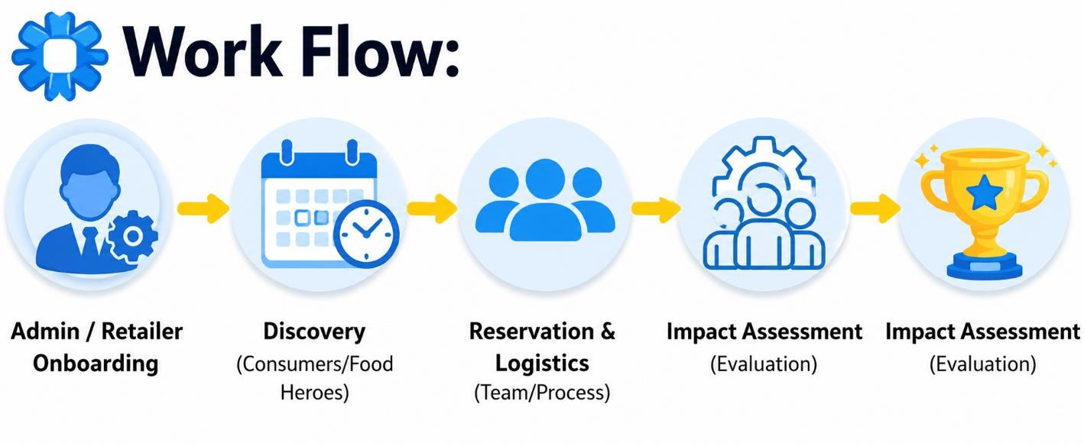
5.3 WorkFlow Diagram

Chapter 6 : Project Scheduling
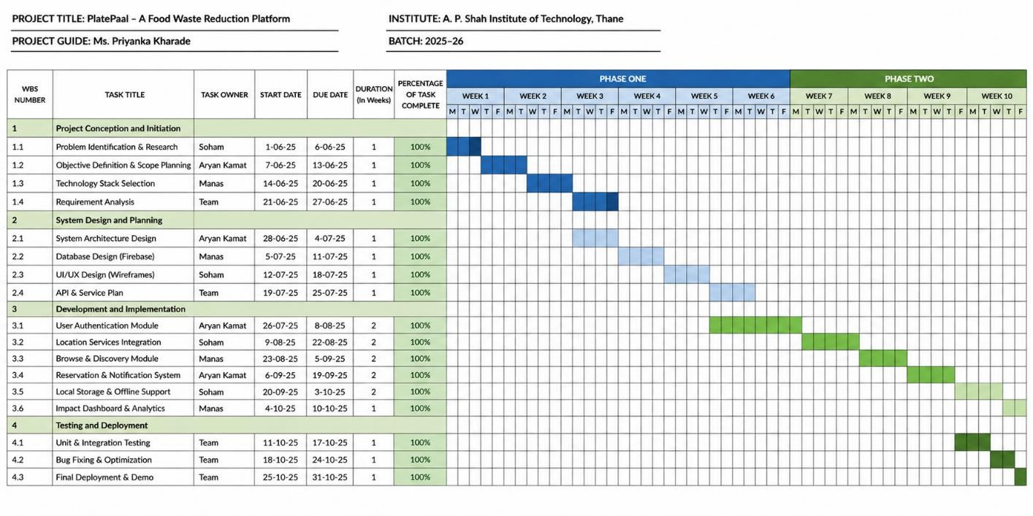
The project is planned over Three months. The Gantt chart below outlines the key tasks and their estimated timelines.

GANTT CHA

Chapter 7 : Results
The platepall platform has been successfully developed and tested as per the definedobjectives. All core modules: Admin, reservation and Aimapact assment are fully functional and integrated.

7.1Technical Achievements
- Successfully implemented a unified cross-platform codebase with zero platform-specific UI bugs.
- Integrated a Complex Build Pipeline using the latest Android tools, resolving circular evaluation and Kotlin binary metadata conflicts.
- Achieved Seamless Real-time Simulations for driver tracking and environmental impact calculation.

7.2 Social & Environmental Impact
- Developed a working prototype capable of facilitating food rescues across various categories (Bakery, Meals, Groceries).
- Created a transparent Impact Engine that provides users with a sense of ownership over their environmental footprint.

7.3. Conclusion
PlatePal successfully demonstrates that technology can be a powerful ally in the fight against food waste. By reducing the friction between surplus supply and community demand, we have created a scalable tool that is ready for real-world pilot testing.The project meets all original objectives and provides a robust, scalable solution for hackathon collaboration and mentorship.

7.1 login screen

PlatePal is a sustainable food rescue application built with Flutter that connects local retailers with eco-conscious consumers to prevent perfectly edible surplus food from being discarded. The platform facilitates the sale of discounted "Surprise Bags," allowing bakeries, cafes, and grocers to recover costs while providing affordable, high-quality meals to the community. By integrating Google Maps and precise geolocation services, users can easily discover nearby rescue opportunities and track their pickups in real-time through an intuitive, Material 3 interface. A core feature of the app is its advanced Impact Engine, which quantifies environmental contributions by visualizing kilograms of food saved and CO2 emissions prevented through interactive data charts.

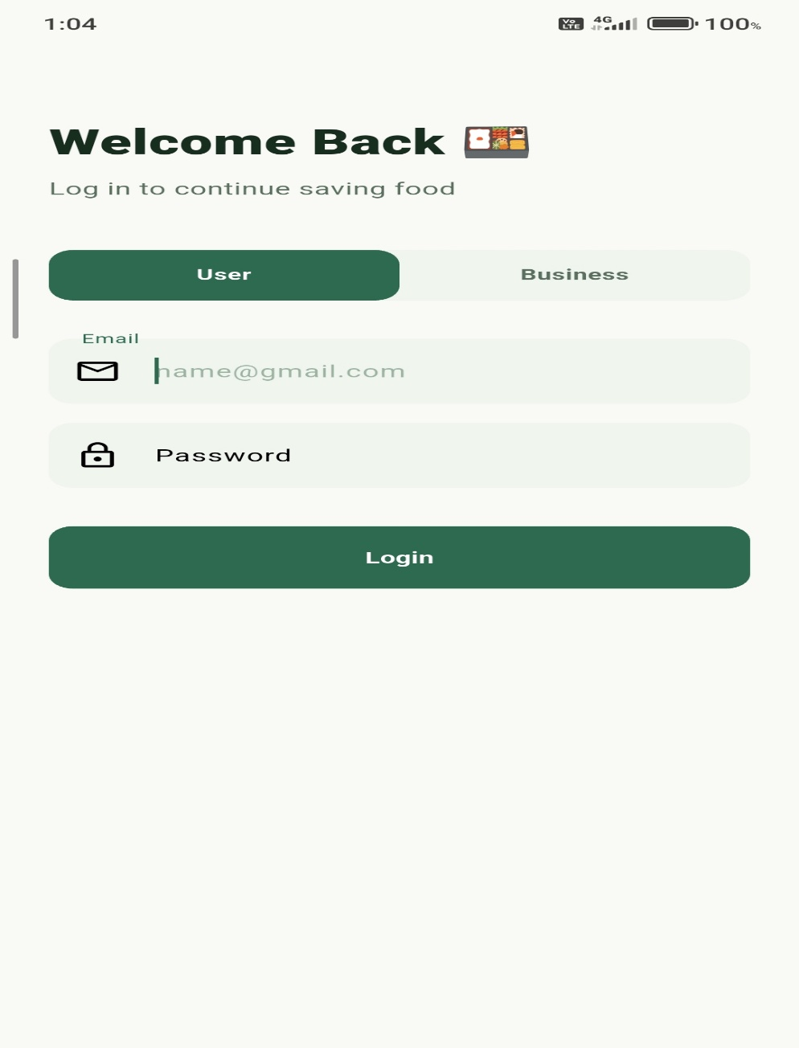

Fig 7.1 : Login Screen
7.2 Admin Panel

The PlatePal Admin Panel serves as a centralized management hub for retailers to oversee their store's surplus inventory and daily "Surprise Bag" listings. It provides a streamlined interface for adding, editing, and monitoring stock in real-time, ensuring that end-of-day food items are quickly made available to rescue. Beyond logistics, the panel offers critical business analytics, allowing shop owners to track revenue recovery and their cumulative contribution to food waste reduction. This secured module is integrated with the core state management system, providing a high-performance tool for local businesses to optimize their sustainability operations
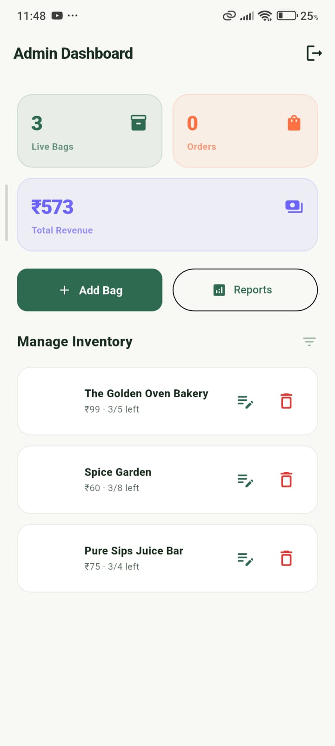
Fig 7.2 Admin Panel

7.3 Dashboard.

The provided main.dart file serves as the core entry point for the PlatePal application, orchestrating the initial setup and global configuration required for a professional mobile experience. Within the asynchronous main() function, the app ensures that essential services—including the Notification Service and system UI overlays—are fully initialized before execution. To maintain a modern aesthetic and consistent user interface, the code locks the device to a portrait orientation and configures a transparent status bar. The root PlatePalApp widget leverages the Provider pattern to inject a global state into the application, ensuring that data such as user sessions and food rescue statistics remain reactive and accessible across all modules. Finally, the MaterialApp is configured with a centralized theme and a robust routing system that seamlessly directs users from the Splash Screen to their respective dashboards, whether they are consumers or administrative partners.

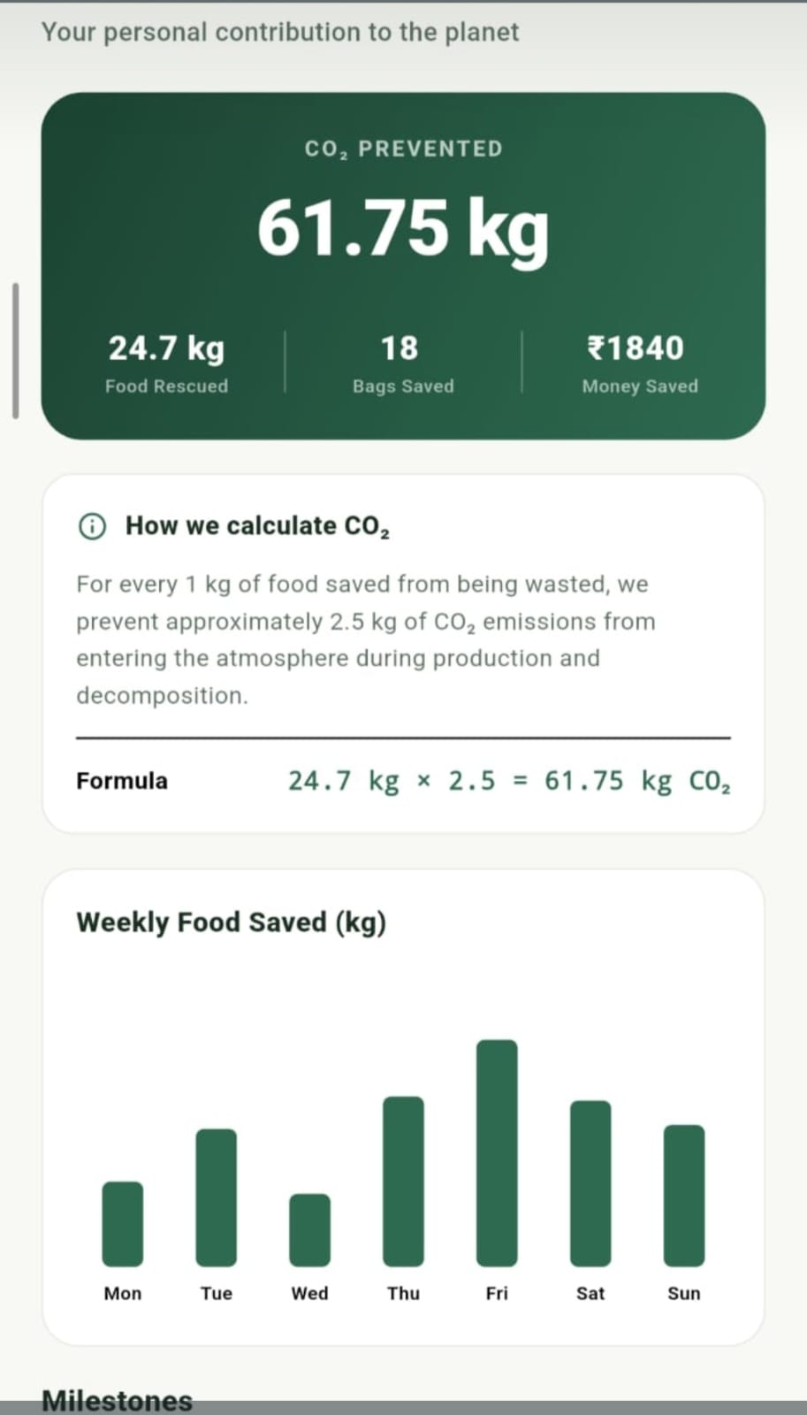

Fig 7.3 Dashboard
7.5 MAP

The PlatePal Map screen provides a dynamic geospatial interface by integrating the Google Maps API directly into the Flutter environment to facilitate local discovery. By leveraging the geolocator package, the application fetches the user's precise coordinates to identify and display food rescue opportunities within a convenient, walkable radius. Each participating retailer is represented by interactive markers, allowing users to instantly view details about available "Surprise Bags" and their current stock levels. This high-performance mapping system ensures that users can navigate seamlessly to cafes and bakeries, effectively minimizing the time between reservation and physical pickup.

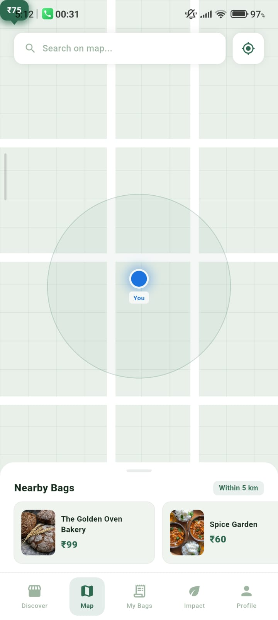

Fig 7.4 Maps

Chapter 8 : Conclusion
The PlatePal project successfully demonstrates how mobile technology can be leveraged to solve one of the world's most pressing environmental challenges: Food Waste.

By creating a frictionless, hyper-local marketplace for surplus food, we have achieved a "Triple-Win" solution:

Environmental Win: Quantifiable reduction in landfill waste and CO2 emissions. Social Win: Affordable, high-quality food accessibility for the community.
Economic Win: Cost recovery and new customer acquisition for local small businesses.

From a technical perspective, PlatePal is a robust, production-ready prototype built on a modern Flutter architecture. The project successfully navigated complex native integration challenges, utilizing Android 25 (SDK 36) standards and a high-
performance Kotlin 2.3 build pipeline. Our implementation of real-time geospatial tracking and local data persistence ensures a reliable, enterprise-grade user
experience.

In conclusion, PlatePal is more than just an application; it is a scalable platform that transforms a logistical problem into a community-driven environmental victory. It proves that with the right technical tools, we can bridge the gap between commercial surplus and human need, making sustainability a convenient daily habit for everyone.

References:
- Flutter Documentation. (2025). Flutter SDK. Retrieved from https://flutter.dev/docs
- Firebase Documentation. (2025). Firebase. Retrieved from https://firebase.google.com/docs
- Dart Programming Language. (2025). Dart. Retrieved from https://dart.dev
- University of Mumbai Syllabus – Second Year Engineering (Data Science). (2025).

